PROJECTS

On selecting ‘Projects’ RM should enable ‘New’ not intuitive to select ‘File’

Okay. Had used word as a basis, there you go ‘file’ then new. But happy to change. Takes out any possibility of uncertainty.

Font of ‘Description’ is different to ‘Name’

Have raised this with Damian already. (is the same on a tablet)

Once a ‘Project’ has been defined it is not possible to open the editor again.

This is done by clicking the name of the project under the tree. (Works for existing)

SYSTEM EDITOR

Font of ‘Description’ is different to ‘Name’

As above – already raised

On invoking the ‘System Editor’ the editor should automatically create a ‘parent function’ with the same name. The reason for this is to eliminate unnecessary or unintended systems from being generated. A difference of a single character will create two different systems.

Do you mean parent function? Or parent system? I can think of examples where the system we are doing the safety case for may not be the parent function – for example with Lorenzo, if the assurance was for just one deployment unit (eg. IPPMA) of the wider system.

But would be useful to default this (in the same way the bowtie defaults the hazard) but make it editable.

On creating a new component, is it possible for the name to be automatically active such that it can be overtyped to uniquely identify the component rather than having to select with a further mouse press.

You mean remove the ‘system’ and ‘function’ labels so it is just the picture? I would prefer maybe for the labels to remain but automatically disappear when they are clicked to be edited?

Error message when making a second save of the system definition. Note – no changes have been made to ‘Prescribing System’ component.

Why is it recording it as a ‘duplicate hazard name’

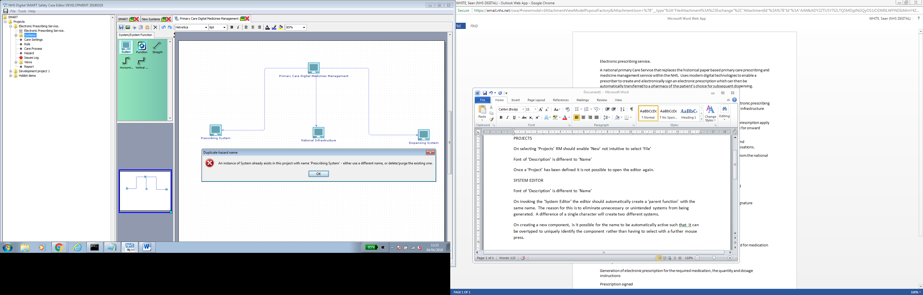

Further amendments cannot be saved

Is it not possible to invoke component editor whilst in the graphical system editor i.e. RM ‘details’

Evaluation stopped and renamed as SMART_new3_040418 on moorfileds pc

*******************************************************************************

New invocation of smart_new3

SYSTEM EDITOR

Another error message

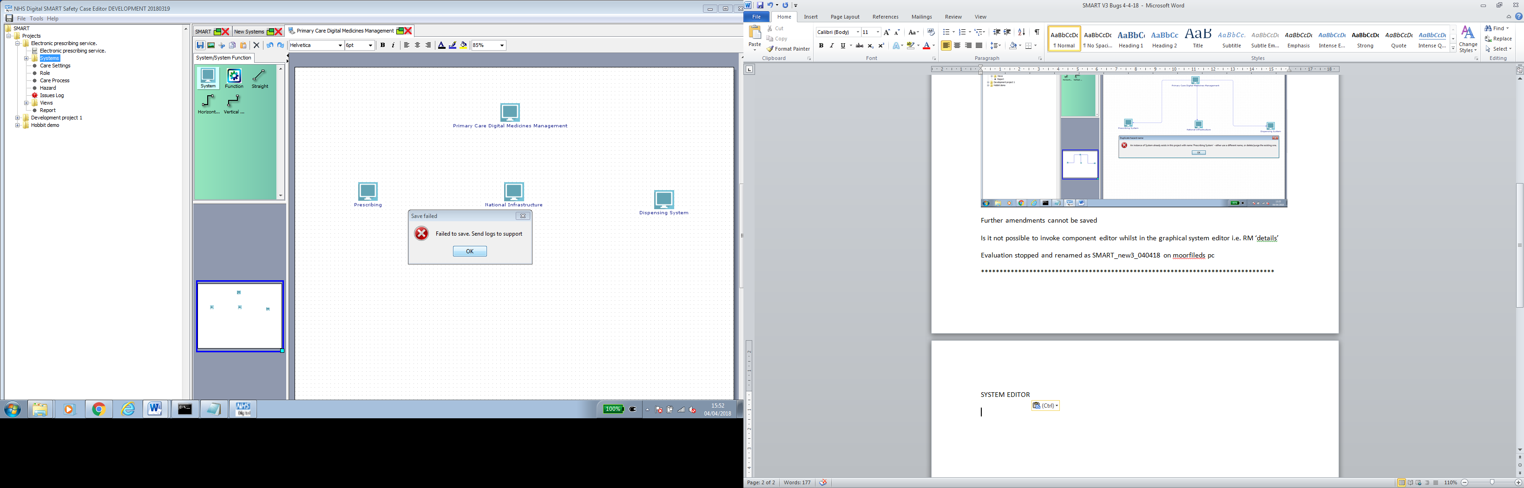

Despite message, schematic saved

Another error message when trying to invoke ‘System & function editor’

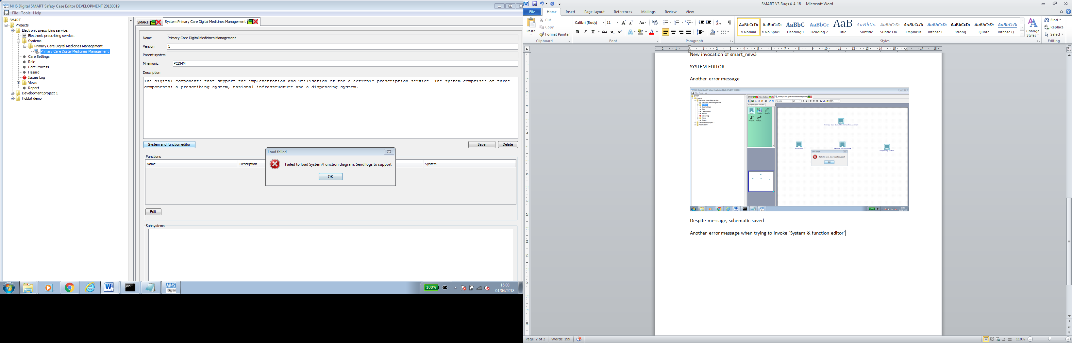

Selecting Ok opens the editor.

RM ‘Link’ does nothing for system or function components.

Subsequent Save generates a familiar error message

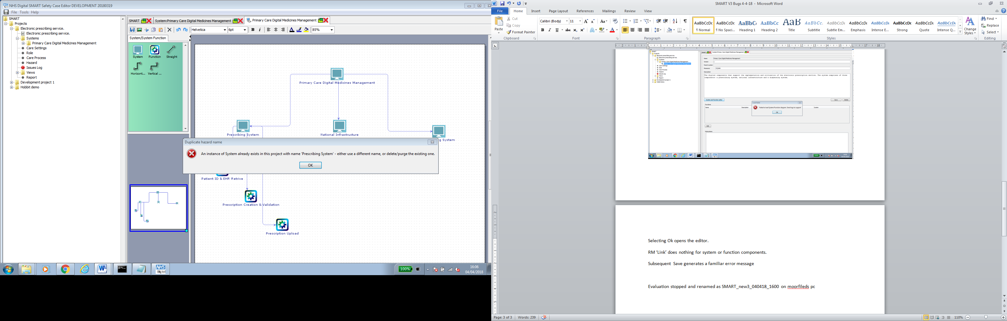

Whilst the components are preserved in the graphical editor they are not reflected in the system definition

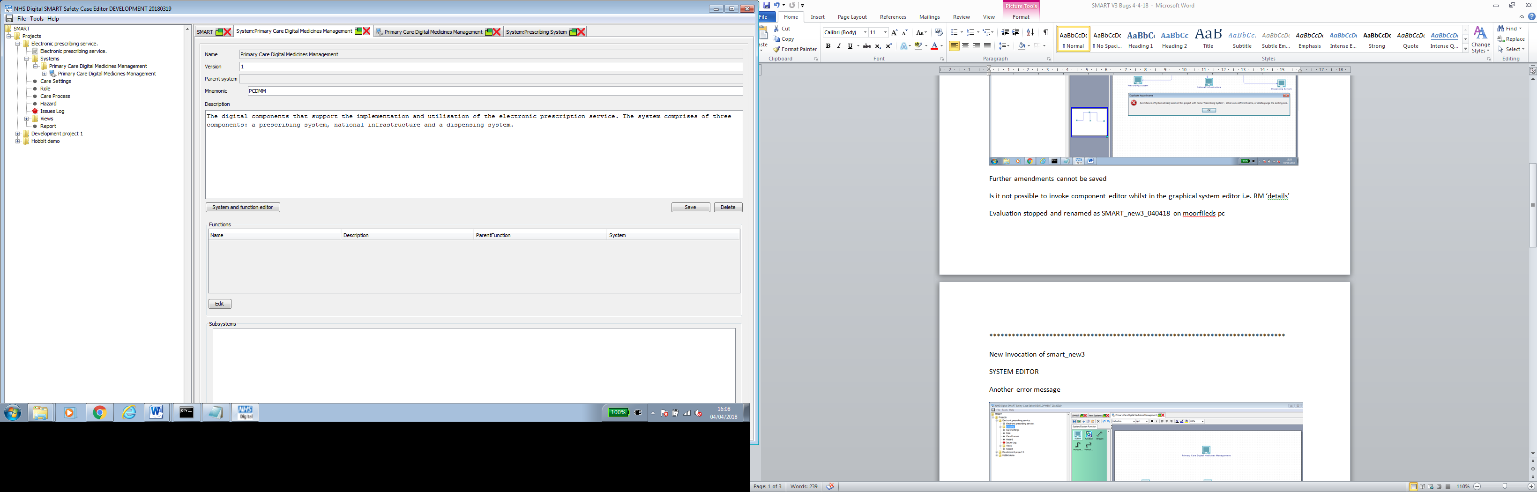

But details are reflected in the subsystem definition

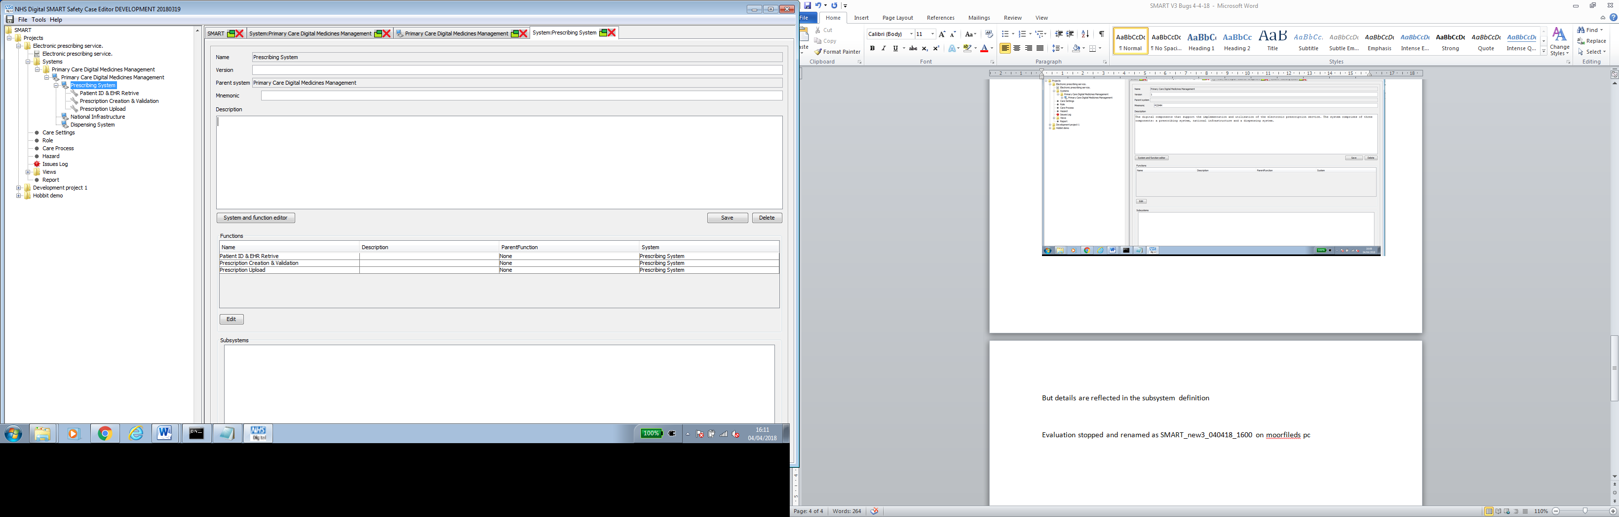

Selecting ‘system and function editor’ generates the following warning which is appropriate – can we not present the option on the form?

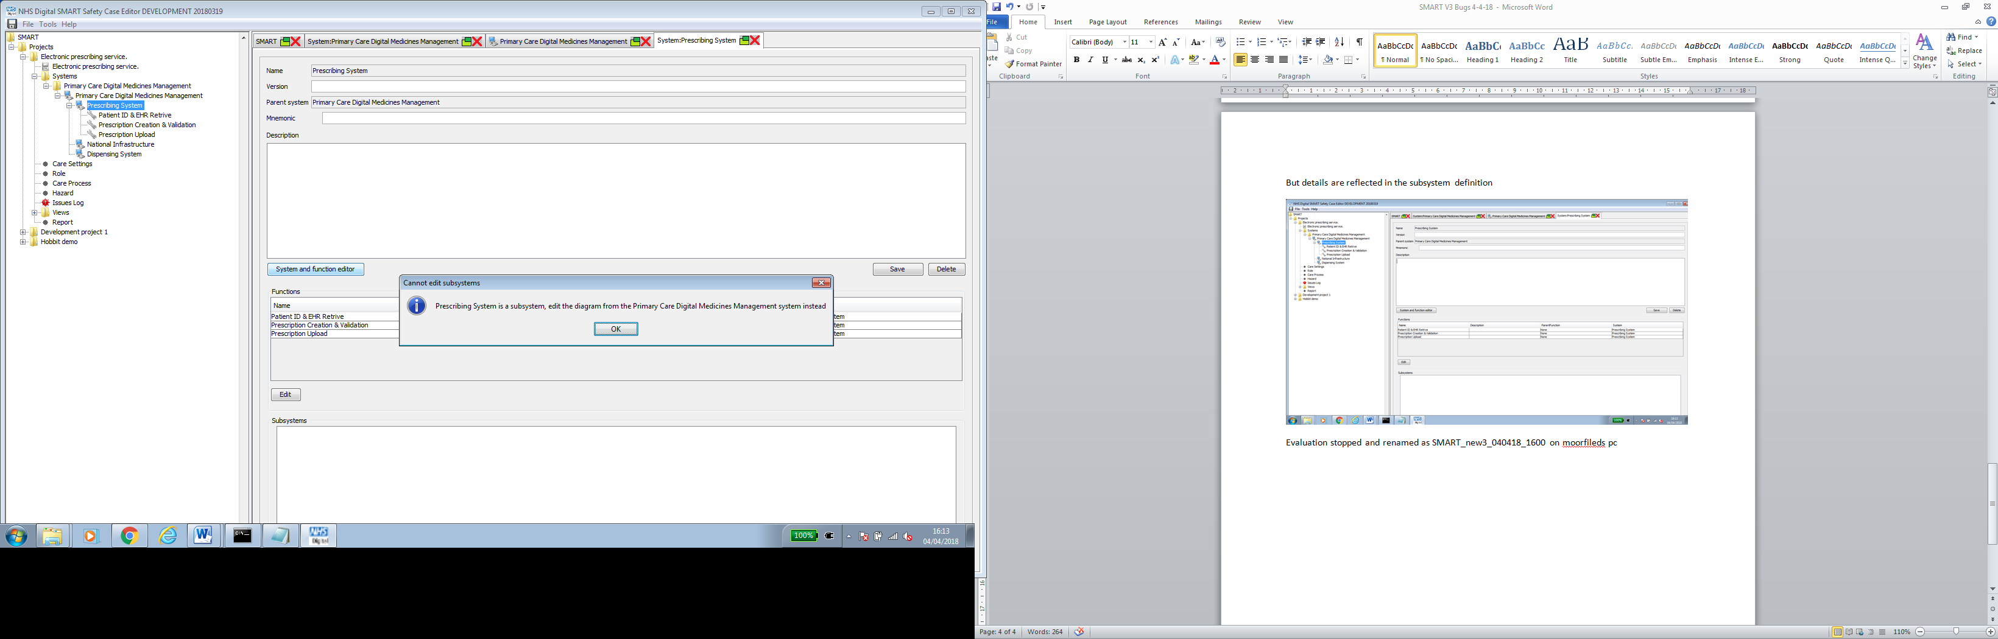

But closing everything down and reopening reveals that subsystem details are recorded

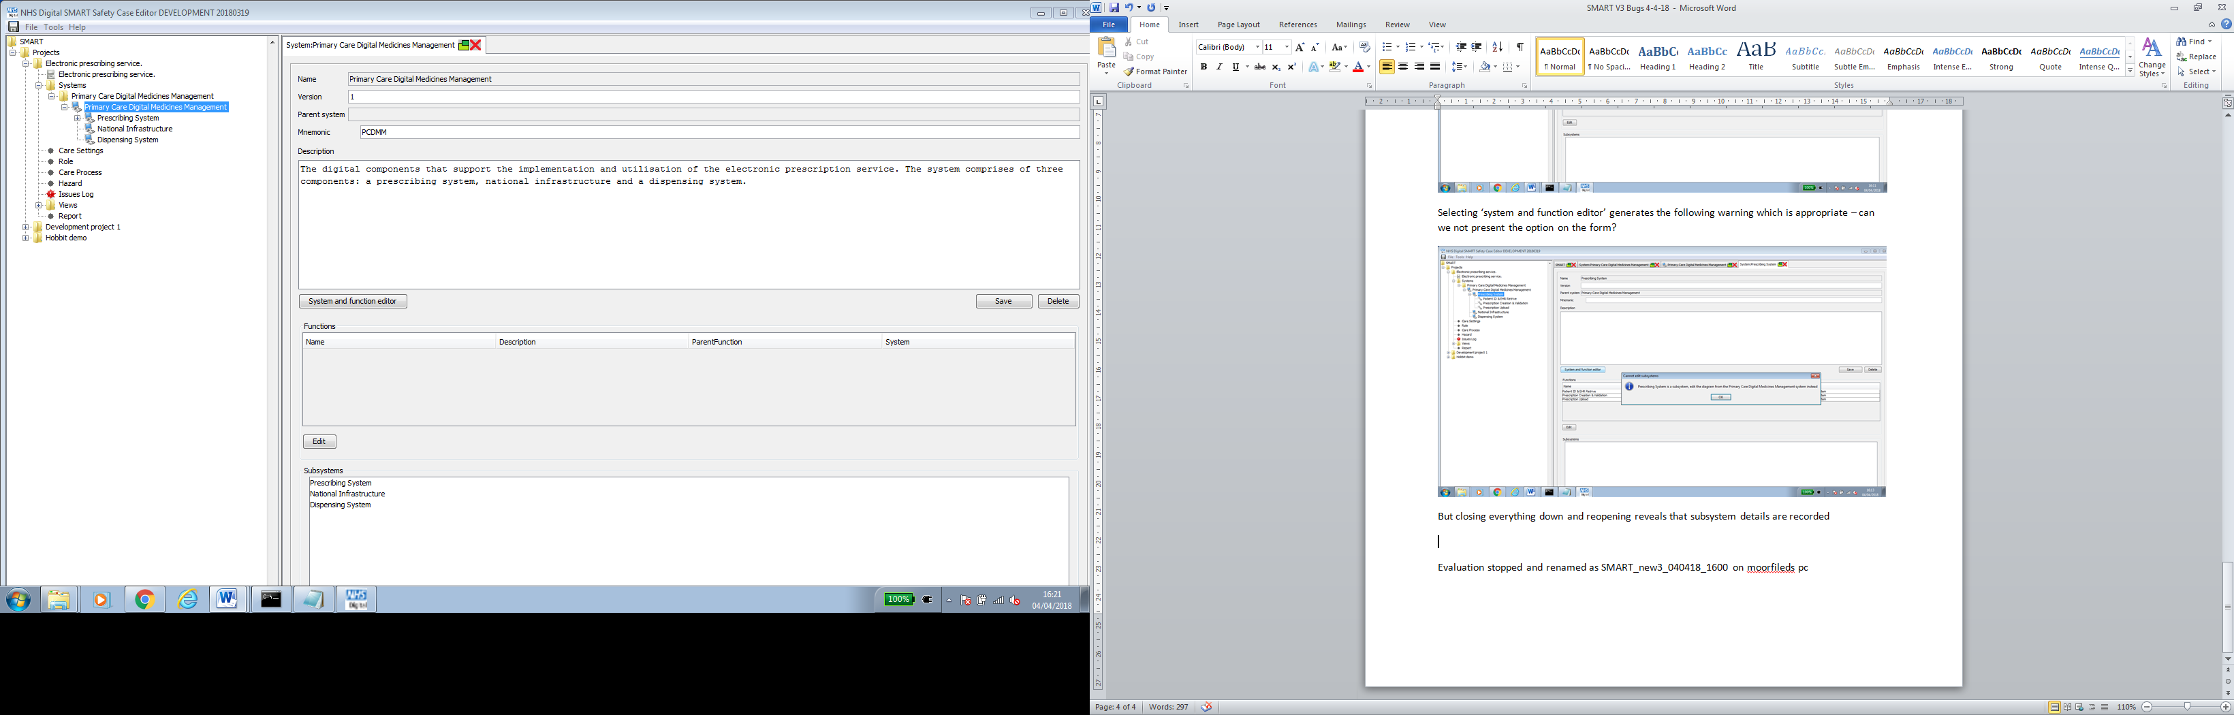

CARE SETTING

Why is ‘Primary Care’ a parent of its self and why is there 2 instances

Is it possible to have a pre-defined ‘N/A’

Within the parent setting? Good idea.

Do we need hierarchical care settings?

I have suggested that we do. Damian did explain to me a reason why it couldn’t, but I can’t remember what it was. Will ask when we present to him

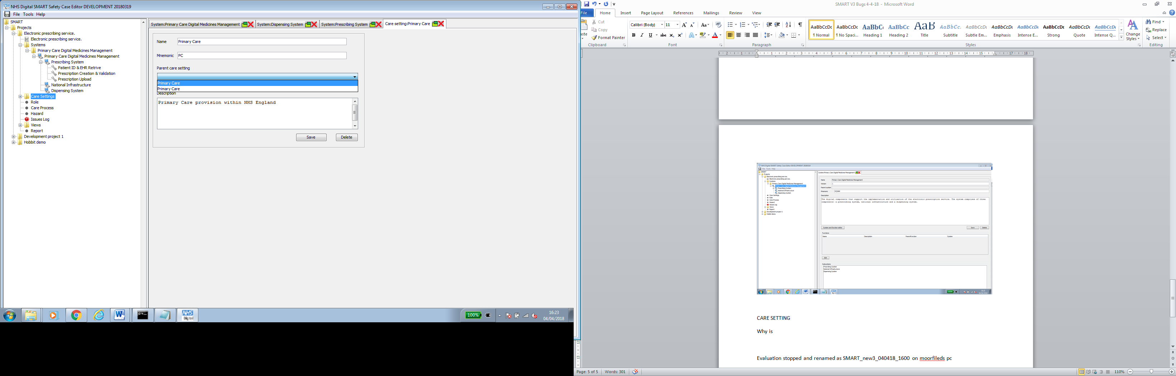

ROLE

What is ‘Category’

Category was present in Ibrahim’s data model so need to confer with him, I have been using ‘patient’ or ‘clinician’ as the categories, but happy to remove if these provide no value

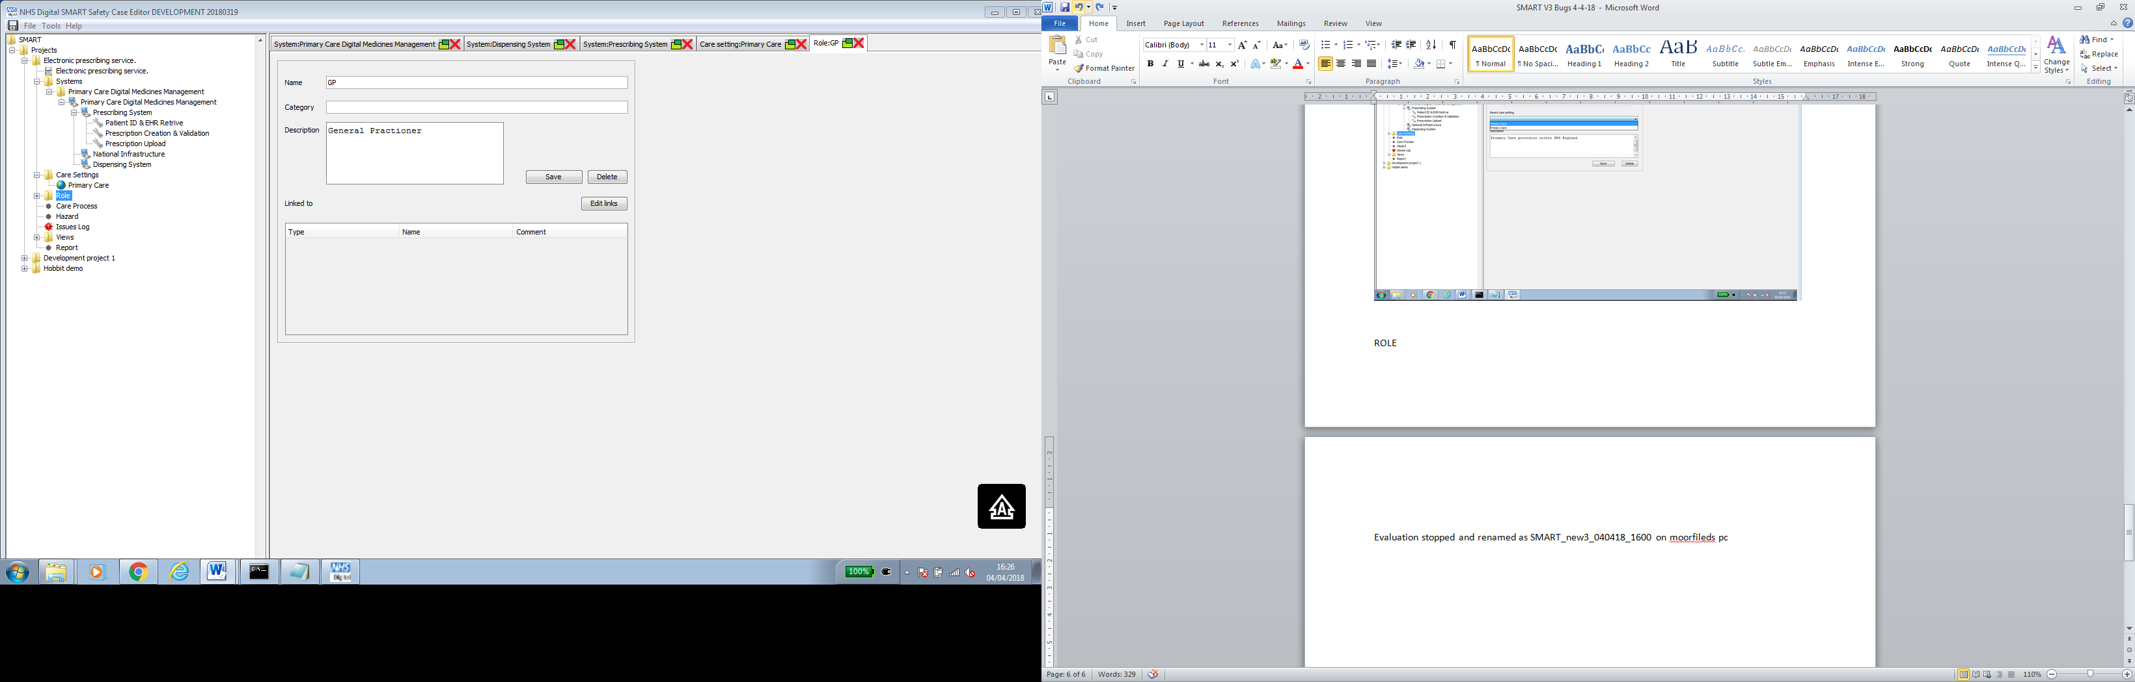

Target Type

Do these only become available once an instance of one has been defined?

Need to link Role to Care Setting, Activity, Decision, Cause, Control

Type ‘Location’ should be ‘Care Setting’

Have raised with Damian – believe this is now fixed

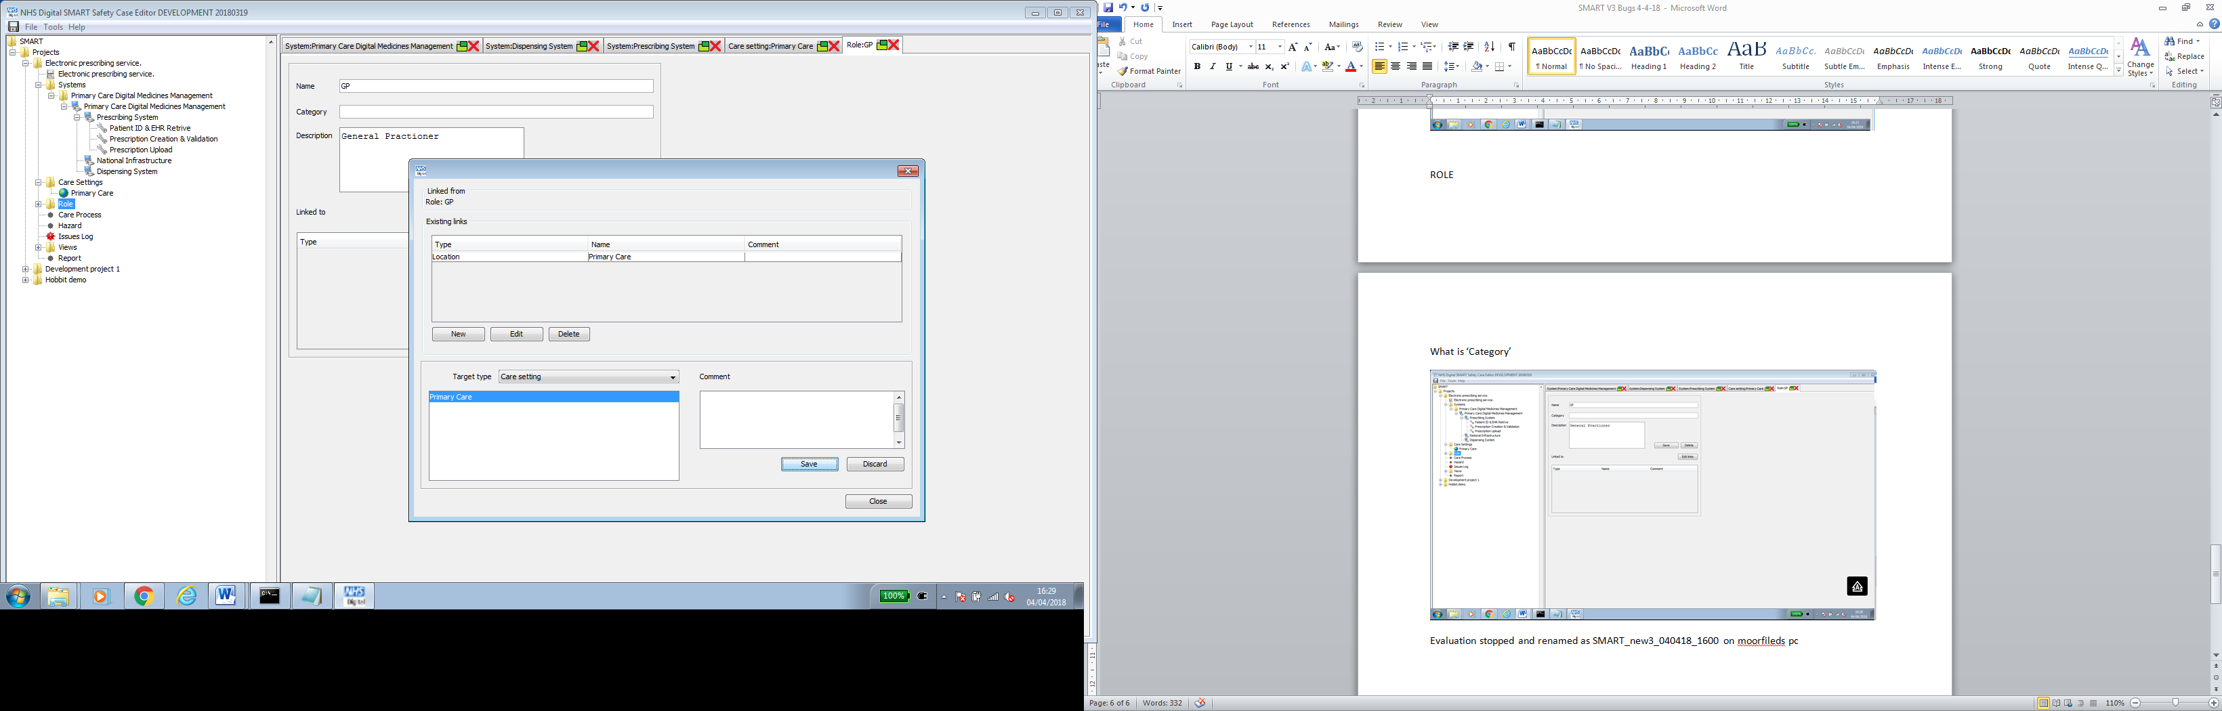

When subsequent ‘save’ is made after adding a comment, duplicate links are created.

This is kind of okay. It saves time going through ‘new’. You can just edit straight away. If you don’t make any changes and press save again, it will just save what’s there. The alternative is that the links editor closes upon save so you’re forced to add new each time?

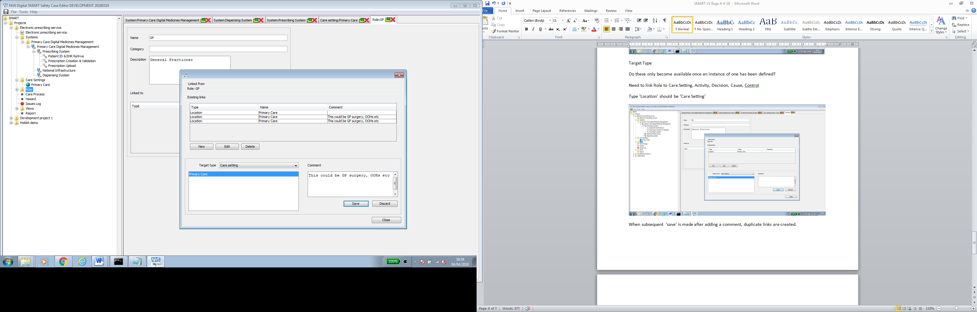

CARE PROCESS

Why do we need a ‘version’

Again in Ibrahim’s data model but happy to remove.

Need a consistent ‘Details’ editor for other editors. Reveals all characteristics/relationships that need to be expressed whilst retain graphical context

Need to understand this better – call details text editor – combine all editors – description, links, hazard etc.

Tabs suggest allowable links but these don’t correlate with the ‘target type’ in the invoked editor. Also, this mechanisation is clunk – is it not possible to establish links directly via the Tabs?

Need to understand this better – reposition links box – match link drop down to tabs.

Also, having defined a ‘function’ the tool should know its relationship to a system

Yes, while not a direct relationship, it is an implied one and so should be triggered automatically once assigned to a function – same with care process from activity/decision

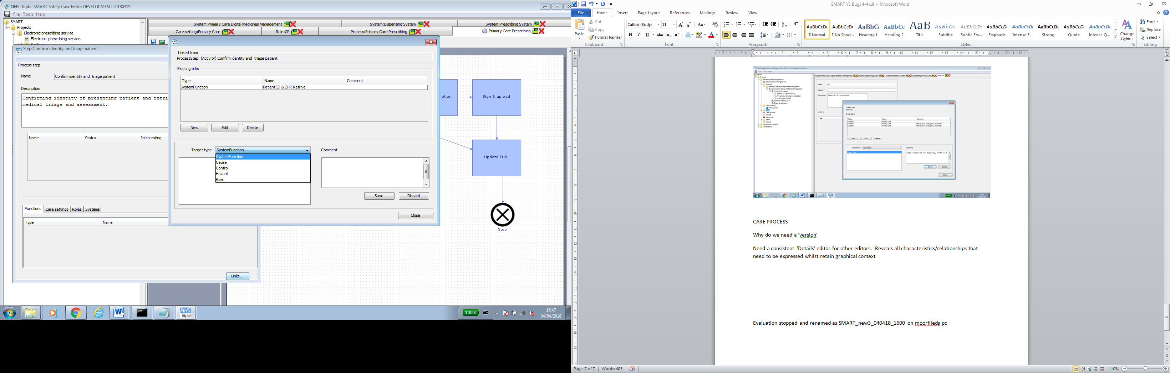

Need to link Activity to Care Process (A) Care Setting (M), Hazard (M), Role (M) Cause (M) Control (M) Function (M) System (A through hierarchical system editor)

Adding components to a care process (bert below) are reflected in the process template

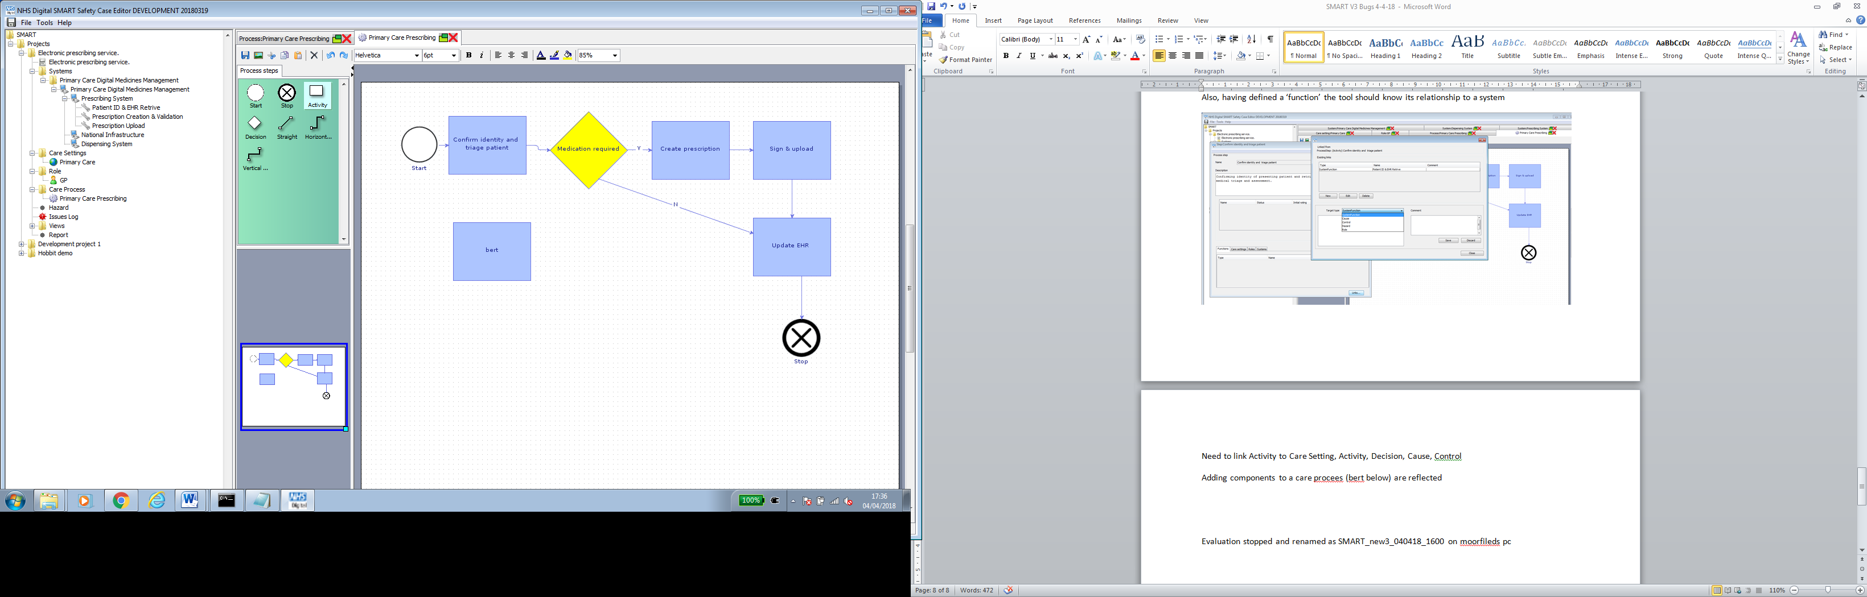

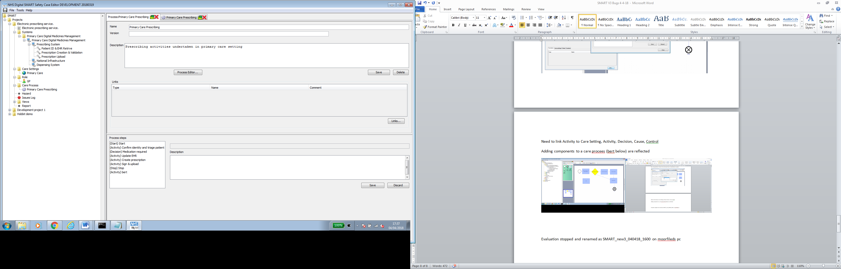

However if bert is then deleted and the diagram saved the change is not reflected in the template and it appears to persist even after closing down the tabs.

Agreed – not deleting on my test either.

HAZRD EDITOR – BOW TIE EDITOR

On invoking the ‘Bowtie Editor’ the editor should automatically create a ‘hazard’ with the same name. The reason for this is to eliminate unnecessary or unintended hazards from being generated. A difference of a single character will create two different systems.

Think this has been done now

CONTROL TYPES

Delete ‘Other’ but enable free text input, delete ‘Test Control’

Agreed. Look at the ‘select’ option too

CONTROL STATE

Should be ‘To be implemented’, ‘implemented’ & ‘Implemented and Verified’

Need new Control data item: ‘existing’ or ‘additional’

Effect – Not sure what ‘Type’

Also remove condition

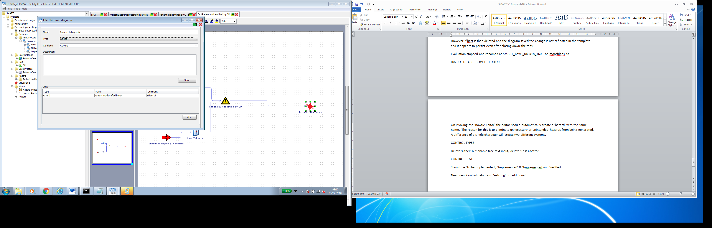

ISSUES LOG

Need Issue Number

Agreed – or reference number

Not sure what ‘Type’ is nor ‘Resolution Type’

I thought this was quite useful – to group issues so can see patterns. For example in Lorenzo we’ve had a load through recently where it was useful to group them into certain types eg. Missing data, confused data, fallback chart. I think it may be useful to keep in but not mandatory and perhaps have some guidance / info / help button nearby with tips